Senior Capstone Design 1

Fall 2022

Green Ellipsis – Upcycling of Single Use Plastic Soft Drink Bottles

Critical Design Review

Marc Caina

Tyler Johns

Antonio Mendoza

Christian Ventouras

Nicholas Wedyck

**Problem Statement**

Single-use polyethylene terephthalate (PET) bottles continue to pack landfills around the country. Because of this, the need for recycling and upcycling of PET grows greater every day. 3D printers can uniquely contribute to this need by upcycling PET bottles into PET filament. Moreover, upcycled PET filament can then be used to 3D print useful items. Green Ellipsis has a solution to this issue that converts plastic bottles into 3D printer filament. Figure 1a shows the current device used by Green Ellipsis. This method of upcycling PET bottles cuts a two-liter bottle into one long strip. The strip is pulled through a heated chamber (Figure 1b) while the bottle is being cut (Figure 1c). This deforms the plastic into usable filament. Currently, the setup for this process is intensely laborious. Furthermore, the user must manually cut off the bottom of the bottle, then cut a strip using scissors and pull it through the pultruder. Therefore, it’s not ideal for hobbyist use, which is the current end goal for the device. To solve the problem of a laborious setup process, automation is required. Figure 2 details all steps in this upcycling process.

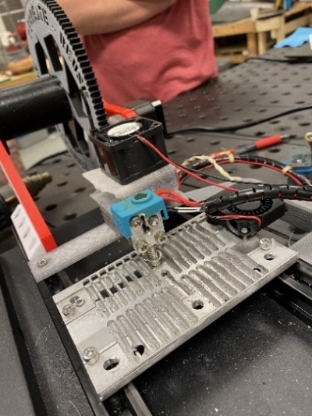

(a) (b) (c)

Figure 1: (a) The overall system (b) The hot end and pultrusion device (c) The PET bottle cutter

Figure 2: Process overview for PET upcycling

Automating one of these steps would reduce the labor required by the user to produce PET filament. More specifically, the laborious setup process benefits the most from automation, as mentioned previously. The setup processes include Bottle Cleaning, Bottle Cutting, and Strip Pultrusion. Bottle Cutting was chosen as the optimal step to automate in the setup process. The method used to make this decision will be described in the Design Alternatives and Decision Making Process section.

As stated in the Background section, the current Bottle Cutting step consists of cutting off the bottom of a two-liter bottle with a blade. Then, an angled starting strip must be cut for the pultrusion process using scissors. Automating this step includes combining both cuts into one. Ideally, this step is completed using a single tool with minimal human operation. The following are the design requirements and constraints that are specifically tailored based on the bottle cutting automation step. Each requirement and constraint were established based on the project description, as well as meetings with Green Ellipsis. All requirements and constraints are measurable to verify the success of the product.

**Design Requirements**

* Reduce duration of reclamation process by 20 percent
* Reduce human interaction by 50 percent for the bottle cutting process
* Bottle cutting process must accept washed two-liter PET bottles
* Must begin the pultrusion strip by cutting an eight-millimeter-wide ribbon from the bottle

**Design Constraints**

* Machine needs to fit in a 75cm by 240cm by 80cm volume
* Must run off standard wall power (120Vac/60hz)
* Users must not be able to cut themselves easily
* Use two-liter Pepsi product PET bottles
* $1,000 budget

The five design constraints listed above are strict limitations of the bottle cutting process that were imposed by Green Ellipsis. First, the size constraint details the dimension constraint on the entire upcycler. So, the bottle cutting machine must be able to fit with the rest of the upcycler on a tabletop within the volume shown. Second, the power constraint limits the bottle cutter machine to a standard U.S. 120-volt wall outlet. Third, the safety constraint addresses the importance of creating a machine that does not easily harm the user. Moreover, the current bottle cutting process has open blades (scissors and X-ACTO knife) that can potentially cut users. Therefore, it is important to remove the user from having to be near the blades when using the machine. Fourth, a general constraint guides the overall design with restricting the types of bottles the bottle cutter machine allows. Two-liter Pepsi product bottles have a uniform mid-section and can therefore be used in the pultrusion process of the upcycler. Finally, a strict budget constraint rounds out the design constraints. A maximum of $1000 will be provided by Green Ellipsis to automate the bottle cutting process.

**Design Alternatives and Decision-Making Process**

Three different concepts were considered. Each concept focuses on a different step in the current setup process. This is because there is a requirement to automate at least one process in the design. Furthermore, it is necessary to focus on the most important and feasible process to automate, given the deadline for this design. The three concepts considered for automation included:

* Bottle cutting
* Bottle cleaning
* Strip pultrusion

Each of the selected concepts was discussed extensively during team meetings. Rough, hand-drawn sketches were generated based on these discussions to get an idea of potential automation solutions. A down selection process was then utilized to narrow the concepts down to one final concept.

**Bottle Cutting**

The bottle cutting stage concept will cut the bottom of the bottle in an automated process. Additionally, this concept includes the beginning pointed strip cut that is needed for the pultrusion process. A couple of factors explain the importance of automating this concept. First, the tool usage would benefit from this concept automation. The current process has the bottom cut and strip cut completed separately using two different tools. Moreover, the user must first use a modified blade to cut the bottom of the bottle off, then a pair of scissors to start the strip cut. Another importance to automating this process is the accuracy between strip cuts. As mentioned, the current strip cut is done with scissors. In addition, this pointed strip cut must be a certain thickness and length in order to properly enter the heated chamber during the pultrusion process. As observed, the current process has a variation in strip cut between bottles. An automated solution would allow for a thickness and length that could be accurately replicated each time.

Figure 3 shows a potential automated solution to the bottle cutting concept. First, the bottle is set into a device with a blade. The bottle or device then rotates automatically, which cuts off the unusable bottom portion of the bottle. Then the y-axis angle of the blade adjusts. Finally, the device or bottle is rotated slightly to cut a pointed strip into the bottle. The accuracy of the pointed strip is crucial to the next step in the process.

*Figure 3: Sketch showing the bottle cutting concept*

**Bottle Cleaning**

The bottle cleaning stage concept includes label removal, adhesive removal, and bottle washing. All these processes will occur within the same stage. There are a couple of reasons why this concept is important to the automation of this design. First, it is necessary to remove all external components from the bottle itself. This is because the bottle cannot enter the heating chamber without the label and adhesive being removed. Likewise, the inside of the bottle needs to be rinsed to ensure there are no contaminants that transfer to the PET filament. Contaminants would cause issues when trying to 3D print using the filament. Another reason of importance is that this process is labor intensive. Currently, the user must cut the bottle label with scissors and peel it off carefully. Then the user must use a rag and D-Limonene solution to remove the adhesive from the bottle. Finally, the inside of the bottle must be rinsed with water. An automated solution would reduce the time spent on this laborious process.

A potential automated solution for the bottle cleaning concept is shown in Figure 4. In this concept, one or more bottles are lowered into a heated solution of D-Limonene. The bottles are then rotated in the heated solution while rubbing against a light abrasive material such as a sponge. This removes both the label and adhesive from the bottle. In addition, the heated solution would also flow around the inside of the bottle during this process, cleaning it. The bottles are then removed from the solution and transferred to the next stage of the process.

*Figure 4: Sketch showing the bottle cleaning concept*

**Strip Pultrusion**

The Strip pultrusion automation process would remove the need to pull the initial filament from the first cut of the PET bottle through the hot end as well as guide it to the winding spool. Afterwards, the winding of the spool would drive the pultrusion process instead of the initial rollers. By automating this process, it would reduce the number of tools and human interactions needed by eliminating the need for pliers to start the pultrusion process. This keeps the hands of the operator away from the heating element, ensuring a safer design. Additionally, this will reduce the cycle time for the entire process as it needs to be manually started for each bottle being upcycled.

Figure 5 shows the first iteration of the automated strip pultrusion process. As the cut strip is set into the pultrusion guides, the rollers would grab the strip and push it throughout the process until it passes the heating element and is wound on the spinning spool. The rollers would also have guides that ensure the filament stays on track because it tends to curve.

*Figure 5: Sketch showing the strip pultrusion concept*

**Down Selection Process for Upcycler Automation Step**

A weighted, down selection matrix was used to determine the most suitable concept for the upcycler automation. The Analytical Hierarchy Process (AHP), from *Engineering Design* [1], was employed to generate normalized weights for each criterion. The “AHP’s Ratings for Pairwise Comparison of Selection Criteria” from *Engineering Design* [1, Tab. 7.8] was used to generate the normalized criteria weights. The ratings are listed in Table 1 below. Table 2 shows the Normalized Criteria Comparison Matrix. This matrix was used to determine criterion weight by comparing their impact on design success. Table 3 below depicts the down selection matrix. The matrix uses the qualitative ranking system listed in Table 4 to obtain the most suitable concept. The table includes a value, correlated with a description, which represents how effectively the concept meets the design criterion.

*

*Engineering Design [1, Tab. 7.8]*

*Table 2: Normalized criteria comparison matrix*

*Table 3: Design concept down selection matrix*



*Table 4: Evaluation scheme for down selection matrix*



The “Impact on Duration of Process” criteria ranks how much a concept affects the overall duration of upcycling the two-liter bottles into 3D printer filament. As the production time of the 3D printer filament decreases, its production cost also decreases. Since the major goal of this design is to automate this process to make the filament more economical, this criterion ranked highest alongside the “Human Interaction Needed” criterion. This is because the more a person needs to interact with a process, the less the process can run on its own. Therefore, increasing the labor costs of 3D printer filament production. Since the design is provided a budget of $1000, the “Cost” criterion is ranked second highest. For the scale of this project, $1000 is a sufficient budget, however, to maximize the effectiveness of the design, the cost of each concept is weighted heavier than other criteria.

The “Waste Minimization” criterion was given a moderate ranking as the main design goal of the original process was to minimize waste and pollution in the world. The “Manufacturability” criterion is ranked the same since this characteristic of the design affects the overall cost of the design. Both “Feasibility while Writing Report” and “Complexity” are ranked with the same moderate value. Since the project entails designing, manufacturing, and testing a design while writing an extensive design report over a nine-month period, the complexity and feasibility of the concept are important criteria. The more complex a concept is, the more time is needed to create a successful design, and the time needed to write the extensive design report is a factor that must be taken into consideration when determining the design concept. The “Automation Risk Avoidance” was also given the same ranking. The ability of the design to reduce the risk of injury for a user can reduce the liability taken on by Green Ellipses.

The “Power Requirement” criterion was given a lower ranking. The design is constrained to run on standard wall power(120Vac/60hz). This is so hobbyists who are interested in creating their own 3D printer filament can run this machine in their own homes. Since the power requirements of the original design are well below what is supplied from standard wall power, the power requirement of the automation design concept is not a major element in the decision-making process. The “Size” and “Testing Time” criteria were ranked lowest. The size requirement given by the sponsor is that the design must fit in a 75cm by 240cm area. The current design takes up roughly 60cm by 45cm, therefore, there is abundant room for the automation component. The “Testing Time” criterion represents the amount of time needed to test the concept once it is manufactured. The amount of time needed to prove a design’s effectiveness contributes to the suitability of the concept but isn’t a defining factor.

**Final Concept Selection**

The down selection process yielded the bottle cutting concept as the final concept. Once all the criteria were normalized and ranked, the down selection matrix was used to determine the final concept. Bottle cutting ranked first with a net score of 4.12, bottle cleaning second with a net score of 3.80, and the pultrusion process last with a net score of 2.93.

There are several key areas that attributed to the bottle cutting concept scoring highest. First, bottle cutting ranked highest on “Cost,” which was weighted second of the twelve criteria. This is important because it means that automating bottle cutting will save the most in cost and will ensure that the budget will not be exceeded. Next, bottle cutting ranked high again for “Human Interaction Needed” and “Impact on Duration of Process,” which were tied for the highest weighted criterion. This shows that the bottle cutting design will benefit most from automation, making that process less labor intensive. All of this leads to the fact that the bottle cutting concept is the design that will be focused on moving forward.

**Bottle Cutting Design Concepts**

After Bottle Cutting was determined to be the ideal process to automate, three design concepts for this process were created. The first design concept is an iteration of the current bottle cutting mechanism. It is a 3D printed sleeve that houses a blade perpendicular to the bottle. The bottle is manually inserted into the sleeve and rotated to cut the bottom of the bottle off. The difference between the current design and the first concept is that the blade will rotate after the bottom of the bottle is cut off to begin the angled strip. Figure 6 shows a conceptual sketch of the design. The benefits of this design are its simplicity and lack of failure points. The design requires no electrical components and minimal moving parts. However, it requires abundant user input to operate. The flexibility of a bottle could also cause issues when initialing the angled cut, especially when the bottom is cut off.

*Figure 6: Bottle cutting design concept one*

Unlike the first design concept, the second design concept will be integrated with the rest of the upcycling process. It consists of two stepper motors, one to actuate the bottle linearly along the Z-axis and one to rotate the bottle about the Z-axis. The bottle will be inserted into a sleeve, similar to the first design concept, and a blade will actuate to cut the bottom of the bottle off. Then the bottle will be lowered to a blade that will cut the rest of the bottle into a strip while the rest of the upcycling process occurs. This design is more complex, however, the only human interaction required is inserting a bottle to begin the process and unloading the remainder of the bottle when the process is completed. Figure 7 shows the preliminary sketch of the concept.

*Figure 7: Bottle cutting design concept two*

The third design concept consists of an arm that grabs the bottle. Within the arm there are rollers to rotate the bottle and blades to simultaneously cut the bottom of the bottle and cut the strip. Similar to the first design concept, this design will be a stand-alone component, meaning it is separate from the Recreator. However, this design will cut the entire bottle into one long strip to be fed into the pultruder, eliminating the need for the bearing cutter used in the current process. A preliminary sketch of this design concept is shown in Figure 8.

*Figure 8: Bottle cutting design concept three*

**Down Selection Process of Bottle Cutting Design**

The down selection process for the three design concepts was done using the same procedure as the automation step down selection process. The Analytical Hierarchy Process (AHP), from *Engineering Design* [1], was employed to generate normalized weights for each criterion. Then a weighted down selection matrix was created to compare the three concepts using the normalized weights. The down selection matrix is shown in Table 5. The criteria used in the AHP are similar to the ones used in the automation step down selection, however, criteria that were not relevant to the bottle cutting process were excluded.

*Table 5: Down selection matrix for three design concepts*



From the down selection process, the second design concept was determined to be the optimal concept to move forward with. Design calculations were then performed on a component level to determine the specifics of the design.

**Design Calculations**

**Power Screw Torque to Raise and Lower the Bottle**

A linear actuator, primarily consisting of an ACME thread lead screw, stepper motor, and a flange nut, was used to move the bottle along the Z-axis. The torque required from the stepper motor to raise and lower the bottle was calculated to determine the torque specifications for the motor. Equations 1 and 2 are used to perform this calculation were taken from *Shigley's Mechanical Engineering Design* [1]. The equations used are shown below, where F is the weight of the load lifted, $d_{m}$ is the mean diameter of the 1/4”-20 lead screw, *l* is the height change per revolution of the 1/4”-20 lead screw, *f* is the coefficient of static friction between the lead screw and the collar, and $α$ is the angle of taper for the ACME lead screw threads.

$T_{R}=\frac{Fd_{m}}{2}\left(\frac{l+πfd_{m}\sec{α}}{πd_{m}-fl\sec{α}}\right)$ (1)

$T_{L}=\frac{Fd_{m}}{2}\left(\frac{πfd_{m}\sec{α}-l}{πd_{m}+fl\sec{α}}\right)$ (2)

These equations were derived from the free-body diagram of an ACME lead screw raising and lowering a load. ACME threads are tapered threads that have superior strength and durability compared to square threads. In order to perform the calculations, it was assumed that the force from the load lifted is uniform across the threads. The results from the calculations are shown in Table 6, while complete calculations are shown in Appendix A.

*Table 6: Torque to raise and lower bottle*

|  |  |
| --- | --- |
| Result | Torque(lb-in) |
| Torque to Raise | 0.107 |
| Torque to Lower | 0.063 |

**Calculation for Self-Locking ACME Threads**

Since ACME threads are used for the lead screw, a calculation to determine if the threads will self-lock when the stepper motor is not applying torque is required. The equation used to perform this calculation was taken from *Shigley's Mechanical Engineering Design* [1]. The equation used is shown below.

Threads are self-locking if:

$f > \tan{λ}$ (3)

where,

$\tan{λ} = \frac{L}{πd_{m}}$ (4)

These equations compare the coefficient of dynamic friction ($f$) between the Stainless-Steel threads and the Acetal plastic collar to the height increased per revolution ($\tan{λ}$) [2]. The dynamic friction was used for this calculation since it is lower than static friction. Therefore, the calculation will give a more conservative result when determining if the friction is greater than the force pulling the lifted load down.

The values calculated for both $f$ and $\tan{λ}$ are shown in Table 7. Since $\tan{λ}$ is less than the coefficient of dynamic friction, the ACME threads are self-locking. The complete calculations are shown in Appendix A.

*Table 7: Results from ACME thread self-locking calculation*

|  |  |
| --- | --- |
| Parameter | Value |
| Coefficient of dynamic friction (*f*) | 0.25 |
| Height increased per revolution ($\tan{λ}$) | 0.07 |

**Torque Required to Cut the Bottle**

The torque to cut the bottle with a blade is required to determine the torque specification for the stepper motor. For this calculation, cutting the bottle was treated as a shear failure between the blade and the bottle. The shear area was assumed to be the thickness of the bottle times the blade tip and the blade shank. This area is shown in the complete calculation in Appendix A. The basic equations used for the calculation are:

$F = A×σ_{shear}$ (5)

$Torque = F×r_{bottle}$ (6)

Where $σ_{shear}$ is the shear strength of PET plastic and $r_{bottle}$ is the radius of the two-liter bottle. The shear strength of PET is 8000psi [3]. The results from the calculations are shown in Table 8.

Table 8: Torque to cut a two-liter bottle

|  |  |
| --- | --- |
| Parameter | Result |
| Shear Force | 3.6 lb |
| Torque | 7.9 in-lb |

**Moment Calculation for NEMA 23 Platform**

A NEMA 23 was previously determined to be used to rotate the PET bottle around the Z-axis as the bottom of the bottle is cut off. Located four inches away from the lead screw and aluminum rods, the weight of the motor will exert a downward force creating a moment where the rods and platform connect. A schematic and a free-body diagram of this are shown in Figure 9a and Figure 9b. The rod and platform are assumed to be rigid bodies. Furthermore, the platform is assumed to be a weightless beam. The equation used to calculate this moment is derived from Static Equilibrium [4] and is as follows:

$M = F×d$ (7)

where,

$F = m×g$ (8)

Here, $M$ is the moment around where the rod and platform connect. $F$ is the downward force created from the mass of the motor, which was found to be 1.5 lbs. [5], multiplied by gravity. And $d$ is the distance from the rod to the center of the motor. The resulting moment was calculated to be 5.9 lb-in. in the clockwise direction. The handwritten calculation is in Appendix A.

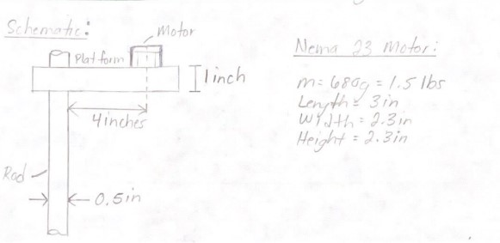

*Figure 9a: Schematic of NEMA 17 motor platform*

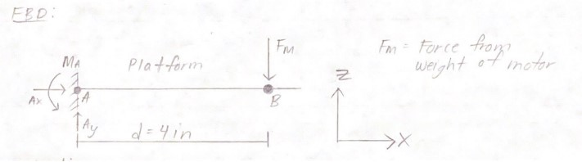

*Figure 9b: Free-body diagram for the moment of platform*

**Puncture Force**

The cutting device shown in Figure 10a, consisting of a linear solenoid and a blade, is used to puncture and cut a 2-liter bottle. The puncture force of this device is required to specify the necessary push force of the solenoid to ensure the bottle will be punctured. A free-body diagram of this is shown in Figure 10b. Assuming that 50 percent of the sharp edge of the blade punctures through the bottle and neglecting the friction between the blade and the bottle, while also neglecting the resistance force of the bottle wall, the following equation was derived [6]:

$F = P×t×σ_{shear}$ (9)

Here, $F$ is the puncture force required to pierce the bottle, $P$ is the perimeter of the hole created from the dimensions of the blade [7] (Figure 6), $t$ is the wall thickness of the bottle [8], and $σ_{shear}$ is the shear strength of the PET material [3]. The result from the calculations provided a puncture force of 2.208 lbf, therefore, the push force of the linear solenoid is required to be higher than 2.208 lbf.

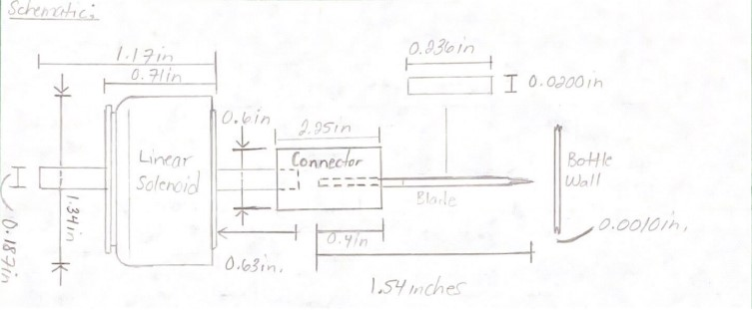

*Figure 10a: Schematic of cutting device*

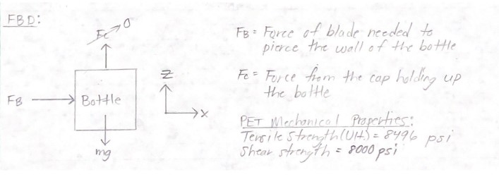

*Figure 10b: Free-body diagram for puncture force*

**Power Supply Calculations**

The PET upcycler’s motors based on the previous calculations are NEMA 17 and NEMA 23. Driving these stepper motors will be a Creality’s Ender 3 mainboard. This Maximum Power Consumption of the mainboard is 277 Watts with an average draw of 125 Watts [9]. Using a 400-watt power supply will be more than enough to power the main board.

$Power = Voltage × Current$ (10)

All peripherals will be driven through the main board which is supplied by the 400-watt power supply and can deliver a maximum of 16.66 amps of peak current. Given a max power draw of 277 watts and an average draw of 125 watts, the provided power supply will provide adequate power to the device.

Another consideration is the linear solenoid which has a max power draw of 21 watts. As shown in Appendix B, the push-pull solenoid will be connected via the designated heated bed port. The heated bed normally draws power in two states, ramping up temperature and maintaining temperature. The maximum power draw when ramping up is 142 watts and is the most power intensive part of the printer. In the maintain temperature operation, it draws approximately 9 watts [10]. With this arrangement, the solenoid will have an adequate power supply from the heated bed port.

**Proposed Design**

As noted in the Down Selection Process of Bottle Cutting Design section, design concept two was selected as the final design to move forward with. The operational flow chart for this final design is shown in Figure 11 below. This flow chart details the interaction between the user and the device. Also detailed is the operation of the device after the user has initiated the bottle cutting automation process.

Figure 11: Operation flow chart for typical user input and normal system operation

**Device Operation**

A CAD drawing that shows the final device along with a parts list is shown in Appendix C. The final design will automate the bottle cutting process through a series of steps. There are four major steps to the final design: user setup, bottom cutting, linear actuation, and strip cutting. These steps are critical to the final design and will therefore be explained more in depth below.

**User Setup**

The first step in this process, before automation, involves a small amount of user setup before automation can begin. After powering on the device and before starting the PET upcycler, the device must return to the starting position. After pressing home on the LCD, the Z-axis motor relocates to the zero point as defined in the program. The platform will translate upwards until it actuates the Z-limit switch, indicating that that platform has successfully moved to the desired location. The user will then need to remove the middle bottle clamp which is used to help with keeping the rigidity of the bottle as it is punctured and cut. Next, the user must twist the bottle into the custom cap. This custom cap allows for the connected NEMA 23 motor to turn the bottle while holding it in place. Once the user does this, the middle clamp can be placed back where it was removed to secure the middle of the bottle. This is the end of the required user interaction with the device.

**Bottom Cutting**

The automation begins at this step once the user starts the device. First, the linear solenoid actuator gets energized and punches the blade into the side of the bottle near the bottom. The linear solenoid was selected as the best way to puncture the bottle as the puncture force is relatively low at 2.2 lbf. Also, a linear solenoid was selected because the blade must be hidden for safety reasons when not in use. Once the bottle is punctured, the NEMA 23 motor begins to rotate the bottle counterclockwise. This rotation direction keeps the bottle tight on the custom cap while the bottle sees a reaction force from the blade. A NEMA 23 motor was found to be necessary, as the required torque to cut the bottle was calculated at 7.9 in-lb. The selected NEMA 23 motor is rated at 10.8 in-lb. As the bottle does a full rotation, the blade cuts through the bottle and the bottom falls off. Finally, the solenoid is de-energized, and the blade is retracted back out of the way of the bottle.

**Linear Actuation**

After the bottom of the bottle is cut off, the bottle moves in the negative Z-direction toward the strip cutter. The system used to maneuver the bottle along the Z-axis consists of a lead screw linear actuating mechanism driven by a stepper motor. Based on the calculated torque required to raise and lower the bottle, a NEMA 17 stepper motor is sufficient. The NEMA 17 motor outputs a holding torque of 2.04in-lb [11]. Figure 12 shows the stepper motor connected to the lead screw. The parts are connected using a size-down coupler between the stepper motor shaft and the lead screw. This was done because the stepper motor shaft has a diameter of 5 mm, and the lead screw has a diameter of 1/4in.

Figure 12: CAD rendering of linear actuating mechanism

ACME threads were chosen for the lead screw because of their self-locking ability at efficiencies lower than 35% [12]. It was calculated that, for the parameters of this design, the lead screw is self-locking. This is beneficial because a separate braking system is not needed for the actuating mechanism. This simplifies the design and reduces the overall cost as no additional parts are needed. A lead screw collar was used to transfer the motion from the lead screw to the bottle. Figure 12 shows the collar attached to the bracket holding the bottle.

**Strip Cutting**

As the bottle is lowered, it becomes surrounded by 3D printed guide tracks. These guide tracks assist the bottle in keeping its integrity when the strip is cut. Then, the bottle will reach a horizontal blade that is encased in the tracks. Once the bottle reaches the blade, the bottle begins to rotate again. Testing will be required to figure out the exact combination of linear actuation and rotation speed in order to get a strip width of eight millimeters. As the eight-millimeter strip gets cut and the blade reaches the top curvature of the bottle, a limit switch will be activated, and the device will stop. At this point, the user can remove the plastic strip and the top of the bottle.

**Manufacturing**

There are seven different parts that must be manufactured for this design. All of these parts will be 3D printed using PLA filament that was supplied by Green Ellipsis. PLA was chosen to be the primary manufacturing material based on the following reasons. Unlike the pultrusion section that must be heat resistant, the bottle cutting section will not experience extreme temperatures. Therefore, PLA plastic can be used. In addition, PLA possesses a well-balanced mix of strength and affordability. As a renewable polymer, PLA is a practical choice for rapid prototyping [13]. Other materials have improved qualities in strength, heat resistance, or shear strength; however, this improved quality comes with additional costs. In a project where the prototypes may be printed over a dozen times, PLA is the only practical solution within budget. The CAD Manufacturing drawings for these parts are located in Appendix C.

**System Block Diagram**

Figure 13 below shows the block system diagram for the PET upcycler. The schematic for this upcycler can be found in Appendix B. Main power is fed into an original Ender 3 board. This board controls two main systems. The first system is the bottle cutting system. This as previously described, takes one two-liter bottle and automatically cuts the bottom off, then cuts the plastic strip needed for the pultrusion process. In addition to software stops, the bottle cutting system utilizes two limit switches. First, the lead limit screw limit switch lets the device know where it is in relation to the Z-axis to prevent damage to the machine. The second limit switch is the bottle runout switch, which lets the machine know where to stop the strip cutting step. This notifies the device that the bottle is used up to prevent damage to the machine.

The other main system in the block diagram is the Recreator system. This system takes the already pultruded material, feeds it through a heat nozzle and forms filament that gets rolled onto a spool. This summarizes the current systems on the PET upcycler.

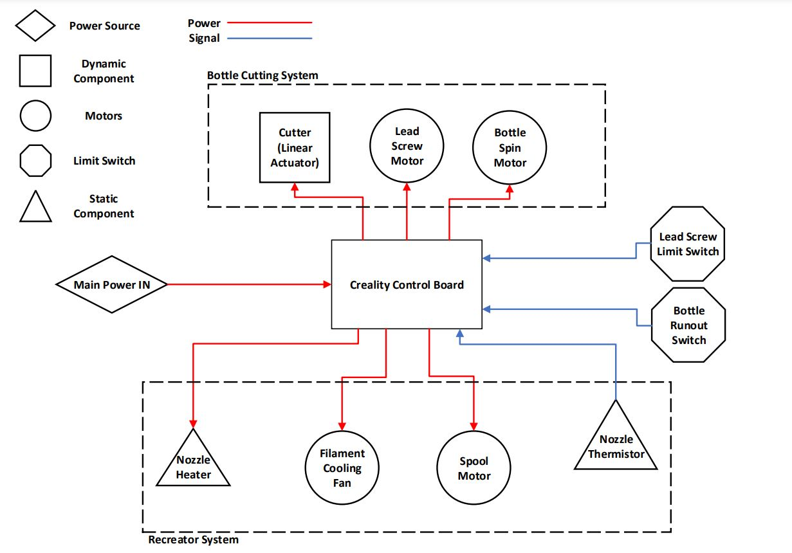

Figure 13: Block system diagram with grouped system functionality

**Gcode Software**

The software used to code the movements of the motors will be Gcode. This utilizes a “G” or “M” prefix followed by an integer to operate the RepRap firmware [14]. Figure 14 shows an example of the code that will be utilized in the bottle cutter operation. G1 is linear movement on a specified axis. Three axis will be utilized, with Z-axis corresponding to Z, Y-axis corresponding to the rotational axis of the bottle, and the E-axis being the rotation of the spool. Codes M190 actuates the linear solenoid to cut the bottle and M1 shuts off the solenoid. Commands M104, M105 and M109 all setup the heating elements for the pultrusion process (which is already implemented for the entire Green Ellipsis upcycling system). M220 will set the speed for the pultrusion process. M82, G92 start the movement of the spool. Lastly is command M808, which is a for-loop that will loop 10 times. In practice this tells the printer to extrude until the pultrusion process stops.

Figure 14: Gcode example for upcycler operation

**Scope of Work / Work Breakdown Structure**

Table 9 below shows the work breakdown structure for the development process of the upcycler automation. In addition, Figure 15 shows the Gantt chart, which better illustrates the exact timeline of the development process. There are eight overarching stages included in the development process, with each stage having sub tasks to be completed.

Team formation and problem definition scope is the preliminary process of defining the values, responsibilities, and problem statement of the project at hand. Concept selection follows the problem statement by brainstorming strong concepts to solving the problem and selecting the best once according to the weighted down selectin chart and AHP chart. The report introduction is the start of the documented project proposal and includes the team formation, problem definition/scope, concept selections as well as any research done to understand the theoretical concepts proposed. Project planning defines the projected course of action for completing the needed tasks of the project by creating a work breakdown structure with Gantt charts and creating a preliminary budget.

The PET Upcycler Design phase is the process of performing initial calculations for the proposed design. This includes any calculations done to determine the material, power requirements, sizing, etc. From this, an initial prototype can be manufactured and tested. The Testing and Analysis phase goes over the iterative process of testing the design, evaluating its performance, and implementing improvements until the design meets the requirements and constraints. Multiple tests are performed in this process including strength tests to ensure they can survive expected stresses, electrical testing to ensure all electrical components are operating correctly, and automation efficiency tests to evaluate how well the design automates the process. During the Final Design and Final Product phase, the final design and accompanying documentation is prepared for the final presentation.

*Table 9: Work breakdown structure for automation of PET upcycler*

Development Process Time (Weeks)

1. **Team Formation and Problem Definition/Scope**
   1. Team Values Statement 1
   2. Problem Statement Version 1 1
   3. Weekly Planning Schedule 1
2. **Concept Selection**
   1. Brainstorming Session 1
   2. Concept Research/Background Knowledge 1
   3. Concept Down Selection 1
3. **Report Introduction**
   1. Brainstorming/Section Selection 1
   2. Research of Background and Theoretical Concepts 1
   3. Problem Statement Revision 1
   4. Written Draft of Report Introduction 1
4. **Project Planning**
   1. Preliminary Work Breakdown Structure 1
   2. Preliminary Budget 1
      1. Cost Breakdown 1
5. **PET Upcycler Design**
   1. Design Review 2
   2. Problem Statement Version 2 1
   3. Configuration Requirements 1
   4. Mid Semester Progress Presentation 2
   5. Initial Material Selection 1
   6. Initial 3D CAD Models 1
   7. Initial Electrical Schematics 1
   8. Critical Design Review Report with CAD, Schematics, 3  
      Flowcharts, Final Work Breakdown Structure Report,   
      Final Project Budget and Bill of Material
   9. Version 3 of Problem Statement 1
   10. Purchase Necessary Materials Required for Testing 1
6. **Prototyping/Testing/Analysis of Mechanical/Electrical Components**
   1. 3D-Print Components 1
   2. Mechanical Testing 1
   3. Electrical Testing 1
   4. Automation Efficiency Testing 1
   5. Brainstorming Improvements 1
   6. Implementing Improvements 2
      1. Update CAD Models
      2. Iterate Until Desired Outcomes Met
7. **Final Design**
   1. Review Final Design 1
   2. Final Design Proposals 16
   3. Final Team Presentations 1
   4. Reflective Writing Assignment 1
   5. Final Team Presentations 2
   6. Purchase Materials Required for Final Design 1
8. **Final Product**
   1. Plan the Construction of the Final Design 1
   2. Manufacturing Necessary Parts 4
   3. Assembling Mechanical Components 4
   4. Assembling Electrical Components 4
   5. Verify Final Design with Requirements and Constraints 1
   6. Prepare and Showcase Final Product/Report 3

Figure 15: Gantt chart of the development process

**Proposed Budget and Bill of Materials**

The overall budget constraint on the design project for Green Ellipsis is $1,000. The accumulated costs will come from the testing of initial designs and the construction of the final proposed design. Current projections for the proposed design have an overall cost of $572.88 (before tax and shipping). This allows for a good buffer in case there are any unforeseen costs that come from design refinements that come during the testing process. Table 10 below shows the Bill of Materials (BOM) below.

The first item on the list is the lead screw which will allow the bottle to be actuated downward. This rounded ACME screw is specially designed for precise automated movement in systems, which is critical when in the strip cutting step in the proposed design. The second item on the list is the flange nut that is specially designed for the lead screw. Moreover, the flange nut will connect to the main part of the design that linearly actuates the bottle. The third item on the list is the 3D printer filament. This PLA filament was supplied by Green Ellipsis, which is why no cost is associated to it. In addition, all of the manufactured parts of the design will be 3D printed using this filament.

The fourth item is the NEMA 23 stepper motor that will be used to rotate the bottle. This motor was determined based on the torque calculations for cutting the bottle. The fifth item is the X-Acto blades that will be used to cut the bottle. A 40 pack was selected as the cheapest option. It also allows for a supply of additional blades once they become dull from extended use. The sixth item on the list is the NEMA 17 motor, which drives the lead screw. A NEMA 17 motor was selected based on previous torque calculations. The seventh item is the clamping shaft collar. Eight of these will be needed to secure the middle clamp and bottom platforms to the support rods. The eighth item is the mounted roller bearing. This bearing will be used to secure the other end of the lead screw while allowing it to still rotate freely.

The ninth through twenty first items correspond to hardware (screws and washers) that is needed to secure various items in this list. All of the hardware comes in either packs of 50 or 100. There will be leftover hardware, however, buying it in packs is an overall cheaper option. The twenty second item on the list is the aluminum rod. This rod will be used as the main holding structure of the machine. Two rods over a foot and a half will be needed, so a six-foot rod will be purchased. The twenty third item is the clamping shaft coupling. This clamping coupling will be used to connect the NEMA 17 motor to the lead screw. The twenty fourth item is the linear solenoid. This will be connected to the blade in the bottom cutter step. Furthermore, this solenoid was selected based on the required puncture force of the bottle. The twenty fifth and final item on the list is the plunger limit switch. Two switches are needed so the actuating part of the design does not exceed the bounds of the lead screw.

Table 10: Bill of materials for proposed design

|  |  |  |  |  |  |  |
| --- | --- | --- | --- | --- | --- | --- |
| **Item** | **Vendor** | **Part Number** | **Package Quantity** | **Price** | **Total Cost** | **Part Quantity for Assembly** |
| Ultra-Precision Lead Screw 1/4"-20 Thread Size, 1 Foot Long | McMaster-Carr | 6350K696 | 1 | 50.68 | 50.68 | 1 |
| 1/4"-20 Thread Size Flange Nut for Ultra-Precision Lead Screw | McMaster-Carr | 6350K171 | 1 | 19.9 | 19.9 | 1 |
| 3D Printer Filament | N/A | N/A | 2 Spools | 0 | 0 | N/A |
| Stepper Motor, NEMA 23, 173.5 in.-oz. Maximum Holding Torque | McMaster-Carr | 6627T53 | 1 | 92.83 | 92.83 | 1 |
| X-ACTO #11 (BladesX40) | Amazon | N/A | 1 | 16.99 | 16.99 | 2 |
| Stepper Motor, NEMA 17, 27 in.-oz. Maximum Holding Torque | McMaster-Carr | 6627T64 | 1 | 72.54 | 72.54 | 1 |
| Clamping Shaft Collar for 1/2" Diameter, 2024 Aluminum | McMaster-Carr | 6157K14 | 8 | 3.67 | 29.36 | 8 |
| Mounted Roller Bearing with Two-Bolt Flange for 1/4" Shaft Diameter | McMaster-Carr | 1434K43 | 1 | 26.06 | 26.06 | 1 |
| Passivated 18-8 Stainless Steel Pan Head Phillips Screw 12-24 Thread, 1" Long (50 Pack) | McMaster-Carr | 91772A296 | 1 | 12.66 | 12.66 | 2 |
| Passivated 18-8 Stainless Steel Pan Head Phillips Screw 6-32 Thread, 1-1/2" Long (100 Pack) | McMaster-Carr | 91772A157 | 1 | 14.6 | 14.6 | 3 |
| 18-8 Stainless Steel Nylon-Insert Locknut 6-32 Thread Size (100 Pack) | McMaster-Carr | 91831A007 | 1 | 6.4 | 6.4 | 3 |
| 18-8 Stainless Steel Nylon-Insert Locknut 12-24 Thread Size (50 Pack) | McMaster-Carr | 91831A025 | 1 | 10.14 | 10.14 | 2 |
| 18-8 Stainless Steel Nylon-Insert Locknut 8-32 Thread Size (100 Pack) | McMaster-Carr | 91831A009 | 1 | 6.9 | 6.9 | 2 |
| Passivated 18-8 Stainless Steel Pan Head Phillips Screws M3 x 0.5mm Thread, 8mm Long (100) | McMaster-Carr | 92000A118 | 1 | 5.51 | 5.51 | 4 |
| 18-8 Stainless Steel Washer for M3 Screw Size, 3.2 mm ID, 7 mm OD (100) | McMaster-Carr | 93475A210 | 1 | 2.19 | 2.19 | 4 |
| 18-8 Stainless Steel Nylon-Insert Locknut 10-24 Thread Size (100) | McMaster-Carr | 91831A011 | 1 | 8.83 | 8.83 | 4 |
| Passivated 18-8 Stainless Steel Pan Head Phillips Screw 10-24 Thread, 3/4" Long (100) | McMaster-Carr | 91772A245 | 1 | 17.32 | 17.32 | 4 |
| 18-8 Stainless Steel Washer for Number 10 Screw Size, 0.203" ID, 0.438" OD (100) | McMaster-Carr | 92141A011 | 1 | 2.4 | 2.4 | 4 |
| Passivated 18-8 Stainless Steel Pan Head Phillips Screw 2-56 Thread, 3/4" Long (100) | McMaster-Carr | 91772A084 | 1 | 4.27 | 4.27 | 2 |
| 18-8 Stainless Steel Nylon-Insert Locknut 2-56 Thread Size (50) | McMaster-Carr | 91831A002 | 1 | 6.15 | 6.15 | 2 |
| Phillips Rounded Head Screws for Sheet Metal 18-8 Stainless Steel, Number 2 Size, 3/16" Long (50) | McMaster-Carr | 92470A091 | 1 | 6.39 | 6.39 | 2 |
| Multipurpose 6061 Aluminum 1/2" Diameter (6ft) | McMaster-Carr | 8974K28-8974K33 | 1 | 9.96 | 9.96 | 2 (20in each) |
| Clamping Precision Flexible Shaft Coupling Spiral, 7075 Aluminum, for 5mm x 1/4" Shaft Diameter, 28mm Long | McMaster-Carr | 2464K17 | 1 | 59.97 | 59.97 | 1 |
| Linear Solenoid, Push or Pull, Continuous, 28 VDC, 120.1 N, 38 ohm, 21 W | Newark | 20M1701 | 1 | 81.07 | 81.07 | 1 |
| Subminiature Snap-Acting Switch Plunger Actuator, SPDT | McMaster-Carr | 7658K19 | 2 | 4.88 | 9.76 | 2 |
|  |  |  |  | **Total Cost:** | 572.88 |  |

**References**

[1] R. G. Budynas and J. K. Nisbett, *Shigley's Mechanical Engineering Design*. New York, NY: McGraw-Hill Education, 2015.

[2] “Acetal copolymer,” *Poly*. [Online]. Available: https://www.polytechindustrial.com/products/plastic-stock-shapes/acetal-copolymer.

[3]“Pet (thermoplastic polyester),” *Poly*. [Online]. Available: https://www.polytechindustrial.com/products/plastic-stock-shapes/pet-thermoplastic-polyester.

[4] C. Luebkeman, “What is a moment?,” *Architectonics*, 1996. [Online]. Available: https://web.mit.edu/4.441/1_lectures/1_lecture5/1_lecture5.html.

[5] “Stepper Motor,” *McMaster*. [Online]. Available: https://www.mcmaster.com/6627T53/.

[6] S. Zhang, “How to calculate punching force? (Free Press Tonnage Calculator & Formula),” *MachineMfg*, 28-Aug-2022. [Online]. Available: https://www.machinemfg.com/punching-tonnage-calculation/.

[7] “Eis: X-acto #11 Blade,” *Engineered & Industrial Solutions*. [Online]. Available: https://www.eis-inc.com/product/blade-ph18-x-acto-11?option=blade-x611-xac. [Accessed: 03-Nov-2022].

[8] M. Wilson, “After 30 years, PepsiCo redesigned the 2-liter bottle,” *FastCompany*, 16-Nov-2020. [Online]. Available: https://www.fastcompany.com/90575332/after-30-years-pepsico-redesigned-the-two-liter-bottle-heres-why. [Accessed: 03-Nov-2022].

[9] “Creality Ender-3 S1 Pro 3D Printer,” *Creality 3D*, 2022. [Online]. Available: https://creality3d.shop/collections/ender-series-3d-printer/products/creality-ender-3-s1-pro-3d-printer. [Accessed: 03-Nov-2022].

[10] F. Arceo, “3D solved,” *3D Solved*, 2021. [Online]. Available: https://3dsolved.com/ender-3-power-consumption/. [Accessed: 03-Nov-2022].

[11] “NEMA size 17 1.8° 2-phase stepper motor,” *Nema17 datasheet*. [Online]. Available: https://datasheetspdf.com/pdf-file/1260602/Schneider/NEMA17/1.

[12] “Engineering characteristics of a Precision Acme screw,” *Engineering Characteristics of a Precision Acme Screw*. [Online]. Available: https://www.helixlinear.com/blog/acme-screws/engineering-characteristics-of-a-precision-acme-screw/.

[13] S. Farah, D. G. Anderson, and R. Langer, “Physical and mechanical properties of PLA, and their functions in widespread applications - A comprehensive review,” *Advanced Drug Delivery Reviews*, 26-Jun-2016. [Online]. Available: https://www.sciencedirect.com/science/article/pii/S0169409X16302058?casa_token=-wRnHFANUycAAAAA%3AdTpZD1VScFj7fhOp67tEq17t1AzaZAA38pgACPlvpc2AuQno5XVSDCJcNyOEbOcAIlhYboPBPA. [Accessed: 04-Nov-2022].

[14] “Cgode command ,” *G*, 25-Oct-2022. [Online]. Available: https://reprap.org/wiki/G-code. [Accessed: 04-Nov-2022].

**Appendix A: Design Calculations**

**Torque to Cut Bottle**

**Torque to Raise and Lower Lead Screw**

**ACME Lead Screw Self-locking Calculation**

**Moment Calculation**

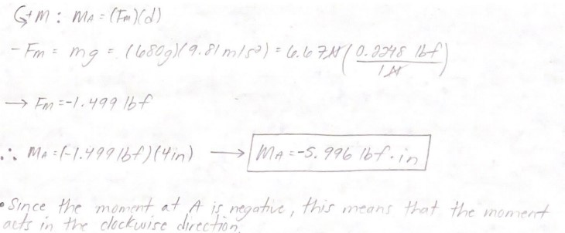

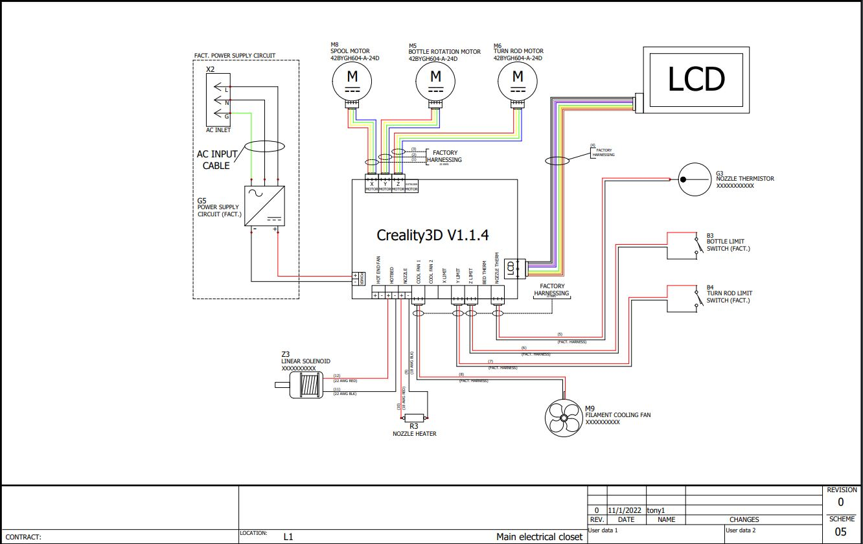**Appendix B: Electrical CAD Schematic**

**Appendix C: Mechanical CAD Drawings**

**Manufacturing Drawings**

